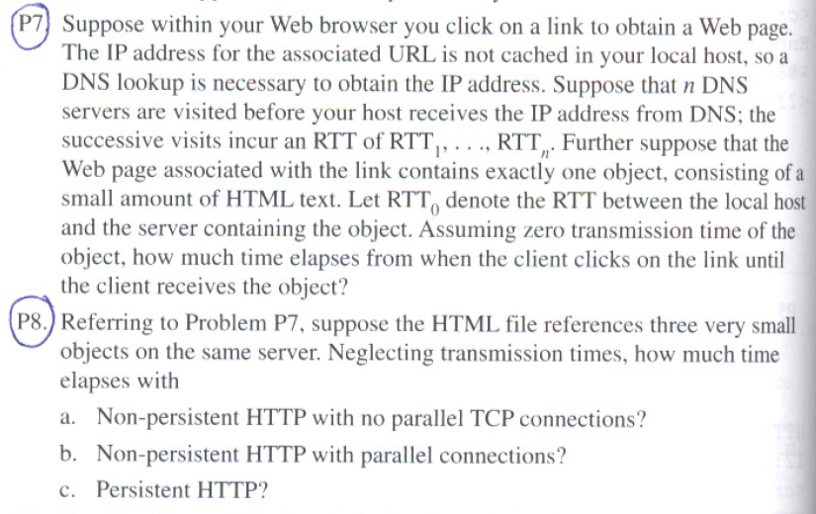

P7.

2RTT0 + RTT1 + RTT2 + … RTTn

2RTTO is used to setup the initial TCP connection and then receive the file.

The RTT1 + RTT2 + … RTTn is used to initially get the IP address of the object.

P8.

1. RTT1 + … + RTTn + 2RTO + 7 \* 2RTTO = 16 \* RTTO + RTT1 + … + RTTn
2. RTT1 + … + RTTn + 2RTTO + 2 \* 2RTTO = 6 \* RTTO + RTT1 + … + RTTn
3. RTT1 + … + RTTn + 2RTTO + RTTO = 3 \* RTTO + RTT1 + … + RTTn